**

**Bridget Thesing**

*Bridget is thrilled to be touring again with Missoula Children's Theatre! She grew up in Kentucky  and graduated from the University of Louisville, where she studied both theater arts and women  and gender studies. Favorite past roles include Molly in Peter and the Starcatcher, Nina in The  Seagull, and Katya in The Fairytale Lives of Russian Girls. When she is not teaching or making theater, Bridget enjoys reading, hiking, and spending time with her sister's puppy. She would  like to thank her family for their constant love and support.*

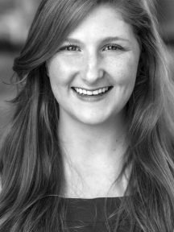

**Nikki Stone**

*Nikki Stone Nikki is absolutely excited to be touring with the Missoula Children's Theatre again! She is an MFA performing arts graduate from Savannah College of Art and Design and holds a BA in theater arts from Lagrange College. Her previous credits include Dionyza in Shakespeare's Pericles, Fanny in On the Verge: or the Geography of Yearning, and Alcyone in Mary Zimmerman's Metamorphoses. She is a resident of Atlanta, GA and would love to thank her family and friends for their endless patience, love, and support.*